LSP980 Product specification

Preface
Thank you for choosing the products of Hangzhou Leshun Information Technology Co., Ltd. In order for you to better use our product, please carefully read this manual before installing and using the product, so as to have a preliminary understanding of the product and follow the necessary operating procedures.
As the product updates or upgrades, the content of this manual will be modified accordingly. The company reserves the right to modify the content of this manual without prior notice. The copyright of this manual belongs to the company and cannot be copied or plagiarized in any form or by any means without permission.

Use the specification
To maintain the best condition of the device and extend its service life, please read this manual carefully before use. The following precautions are required:
1.Observe all warnings marked on the equipment;
2.Stay away from the environment that may easily cause electromagnetic interference or generate static electricity;
3.Use randomly equipped power adapters and batteries;
4.Do not use the same AC power socket with high power or electrical equipment easy to cause voltage fluctuations;
5.Avoid use in direct sunlight, near the heat source, lampblack, dust or corrosive gas places;
6.If there is any liquid sprinkled on the body, please cut off the power supply in time, and wipe it clean with a dry cloth;
7.Do not push other objects from the shell pores into the body, to prevent electric shock or cause short circuit;
8.Clean the appearance of the equipment regularly. Before cleaning, turn off the power switch, unplug the power plug, and wipe it with a slightly wet soft cloth;
9.Properplace the power adapter and power cord to prevent the power cord from being trampled and pulled, causing falling damage to the machine;
10.Please check whether the clock is accurate after each startup. If there is a large deviation (such as more than 5 minutes), it can only be used before correcting the time, otherwise it may cause data confusion;
11.If it is not used for a long time, please clean the machines and tools, keep them clean and dry, put the machines and tools, accessories, user manual back into the original packaging box, and keep them in a ventilated and dry environment;
12.Do not disassemble this product to prevent damage to the machine, lost data, electric shock or other hazards. If you need for maintenance, please contact the service provider;
13.During installation, installation personnel are recommended to wear gloves to prevent scratching screen;
14.If other abnormal conditions occur during use, please record the current equipment status in detail and contact the service provider.

Complete machine introduction
LSP980 is mainly used in group meal consumption scenarios, such as campus canteens, government cafeterias, corporate canteens, commercial canteens, etc. This group dining machine is compatible with palm swiping, QR code scanning, and card swiping simultaneously.
Note: What type of card head or card that the payment card code machine supports, subject to the specific hardware configuration

Product characteristics
- Strong performance
Adopt Qualcomm Snapdragon eight-core processor, fast computing speed, stronger performance.
- Convenient health
Reduce contact with the machine in the payment process, do not worry about infectious bacteria.
- Online upgrade
In addition to the machine can be upgraded through the local OTG and U disk, but also supports network batch upgrade to facilitate the upgrade and maintenance of a large number of equipment.
- The implement clock is automatically calibration
The machine will periodically synchronize the clock with the background server to ensure that the clock error remains within the allowable range, and effectively avoid the data confusion caused by the missynchronization of the clock.

Product Parameter
LSP980 Parameter
Size | 290mm*260mm*105mm
Power Supply | 12VDC/ 3A
Rated power | 18W, maximum of 36W
Work environment | Maximum temperature: -10℃ ~ + 50℃, humidity: 10%~90%  Recommended temperature: -10℃ ~ + 40℃, humidity: 10%~80%
Display | Operation screen: 10-inch IPS LCD screen, resolution: 800 * 1280  Passenger display screen: 5-inch IPS LCD screen, resolution: 480 * 854
Touch screen | Operation screen: 10-inch capacitive touch screen, multi-touch G + G  Passenger display screen: 5-inch capacitive touch screen, multi-touch G + G
CPU | 8-core 1.8GHz A53, Qualcomm Snapdragon 450 processor
RAM | 2GB LPDDR3 RAM
ROM | 16GB eMMC
Audio output | 1.Number of speakers: 1;  2.Rated power of each circuit: 2W @5V / 4R / 1 KHz;  3.Frequency response: 680 Hz ~ ~ 20 KHz;  4.Signal to noise ratio: 86dB@5V / THD = 1% / 1 KHz;  5.SPL：99dB@2KHz/2W
The RTC clock battery | Yes, the power loss can hold the time, and the battery life is> 2 years
Ethernet | Communication protocol: 10 / 100Mbps Base-T adaptive;
WIFI | 1.Communication frequency band: 2.4G / 5G dual channel;  2.Communication protocol: 802.11a/b/g/n/ac;  3.Receiving sensitivity and transmit power:  802.11a TRP≥7 dbm TIS≤-65dbm  802.11b TRP≥10 dbm TIS≤-78dbm  802.11g TRP≥10 dbm TIS≤-67dbm  802.11n TRP≥7 dbm TIS≤-62dbm （5G/2.4G）  802.11ac TRP≥3 dbm TIS≤-62dbm
BT | BT4.2(BR/EDR+BLE)
Cellular network | 1.Communication frequency band:  LTE-FDD：B1/B3/B5/B8  LTE-TDD：B38/B39/B40/B41  2.Receiving sensitivity and transmitting power:  Each frequency band meets: TRP 15dbm TIS-87 dbm  Individual frequency band reached: TRP 19dbm TIS-91 dbm
NFC | 1.Read the card distance of 3~5cm;  2.Read and write time is <0.5 seconds;  3.Operating frequency: 13.56MHz+/-7KHz;  4.UART data transmission rate: 9600 ~ 230400 bit/s  5.The communication protocol is ISO / IEC 14443A / B, ISO15693
QR | Identification distance: 30-150 mm  Support format:  QR code standard: QR Code, PDF417, DataMatrix (ECC200), etc.;  One-dimensional code standard: EAN 13, EAN 8, UPC-A, UPC-E0, UPC-E1, Code128, Code39, Code93, CodaBar, Interleaved 2 of 5, Industrial 25, Matrix 2 of 5, Code11, MSI Plessey, RSS-14, qualified RSS, extended RSS, etc.;
USB Port | 1.Number of interfaces: 2;  2.Interface mode: USB 2.0, type-A interface;  3.Output voltage per circuit: 4.8V~5.2V;  4.Each circuit output current: 500 ~ 600 mA
Palmprint recognition module | 1.Palmprint recognition length distance: 5~12cm  2.QR recognition distance: 3~20cm  3.Camera resolution: RGB 720 * 1024 @ 25 fps, IR 1720 * 1024 @ 25 fps  4.Communication interface: TYPEC (USB2.0 protocol);  5.Power supply: 5V 2A
Cable network interface | RJ45
RJ12 interface | 1.Communication mode: RS232  2.Interface: RJ 12 (compatible with RJ 11)
SIM card interface | Micro SIM Card / 1.8V2.95V is adaptive
Power interface | 5521 DC socket
Appearance color | 1.Color: black / orange;  2.Material: glass, PC + ABS plastic
OS | Android 7.1.2

Product appearance
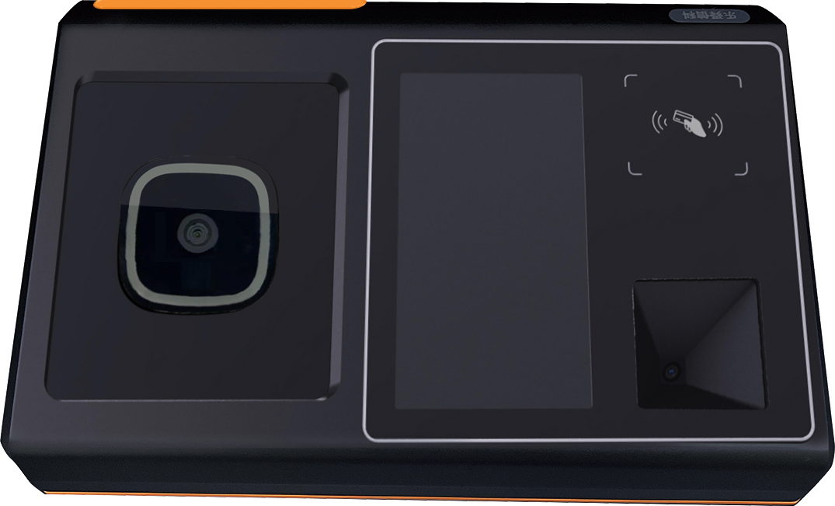

Description of the external interface
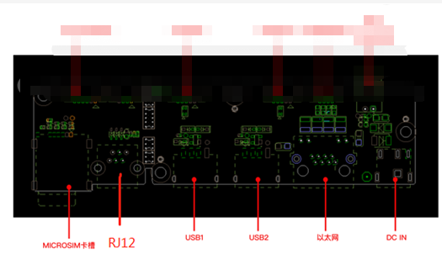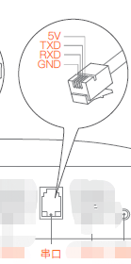
Interface diagram

interface specification:
- The DC12V power supply
 | Terminal electrical definition
Inside is | 12V
External negative | GND

- Standard Ethernet port
- The RJ 12 interface

 | Terminal electrical definition
Pin1 | GND
Pin2 | GND
Pin3 | RS232-RX-IN
Pin4 | RS232-TX-OUT
Pin5 | VDD3.3V
Pin6 | GND

- USB2.0 HOST *2
- Micro SIM Card * 1

Common troubleshooting methods
Below, we will list some common fault phenomena, judgments, and solutions for users to refer to. The list cannot accommodate all fault phenomena, but users can learn preliminary inspection and discrimination methods from it.
Fault phenomenon | Processing method
The Device is not power on | Check the power socket for good contact  Check that the power switch is turned on
The network is disconnected or intermittent | Check that the network cable is well connected  Check the quality of the network wiring and the wiring quality  Check thaCredit card is not workingt the SIM card is well inserted
Credit card is not working | Test the problem using the Whole Machine Test Tool in the system
The button is not working | Test the problem using the Whole Machine Test Tool in the system

After-sales warranty description

During the warranty period, if any non-human failure occurs, the supplier is responsible for providing free warranty service.
However, the following cases are not covered by the free warranty:
1.Failure or damage caused by wrong or improper use, maintenance or storage, such as improper handling, fall or improper external extrusion, contact or exposure of products or parts due to inappropriate temperature, water or wet environment;
2.Fault or damage caused by unauthorized repair, alteration or disassembly by agencies or personnel not authorized by the supplier;
3.Failure to install the equipment according to the product specification or the installation video (including but not limited to all non-standard operations such as drilling of the equipment, which may affect the quality or performance of the equipment itself).
4. Fault or damage caused by force majeure or accident;
5. Other failure or damage not caused by the quality problems of the product itself.
6.Except that it is not covered by free warranty, the supplier shall repair the products free of charge within 15 working days after receiving the products, and mail the products to the buyer immediately, and each party shall bear the freight arising therefrom.
7.For those not within the scope of free warranty, the corresponding maintenance costs and transportation costs shall be borne by the demander itself.

